

**UNIVERSITY OF ASIA PACIFIC**

**Department of Computer Science & Engineering**

|  |
| --- |
| HTTP,FTP,EMAIL Server |

**Course Code :** CSE 320

**Course Title :** Computer Networks Lab

**Submitted by: Submitted To: Name :** Sheikh Nafez Sadnan Md. Akhtaruzzamman Adnan **Reg. No. :** 20101106 Assistant Professor

**Roll No. :** 106 Department of CSE

**Section :** B (2) University of Asia Pacific

How to implement **HTTP Server:**

**At first implement rip2, necessary codes:**

router0:

*route rip*

*version 2*

*network 192.168.1.0*

*network 10.0.0.0*

*ex*

*do show ip route*

Then,

router1:

*route rip*

*version 2*

*network 10.0.0.0*

*network 192.168.2.0*

*do show ip route*

**Step-1:** After configuring the rip2, give ip configuration on http server (server 1).

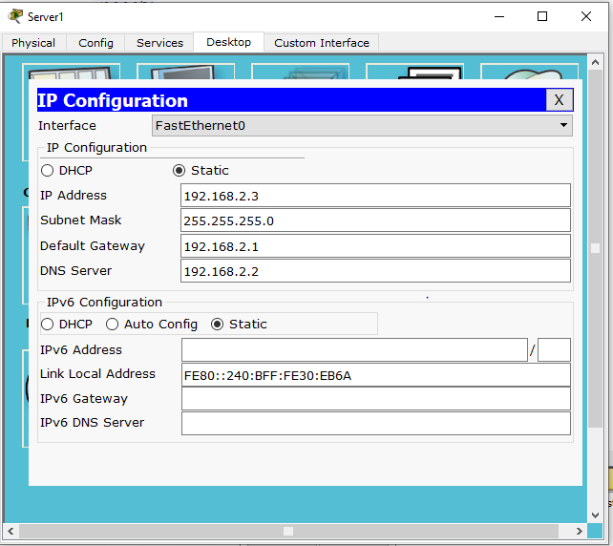

**Step-2:** Go to DNS server on Server 0, give a website name and ip address. Im using [www.uap-bd.edu](http://www.uap-bd.edu) and 192.168.2.3

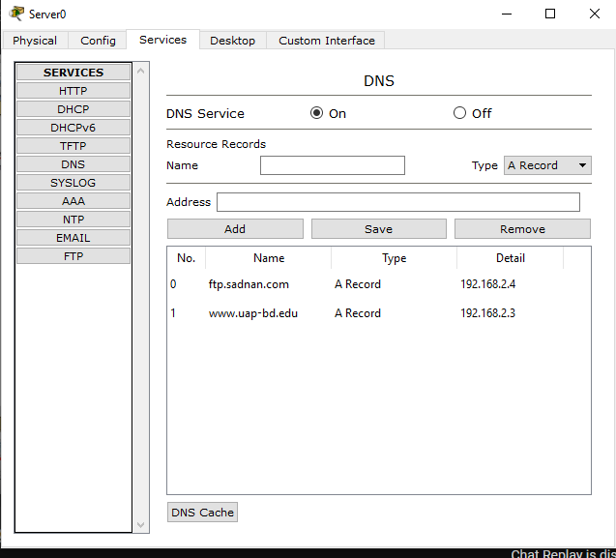

**Step-3:** Edit the index file as per your wish.

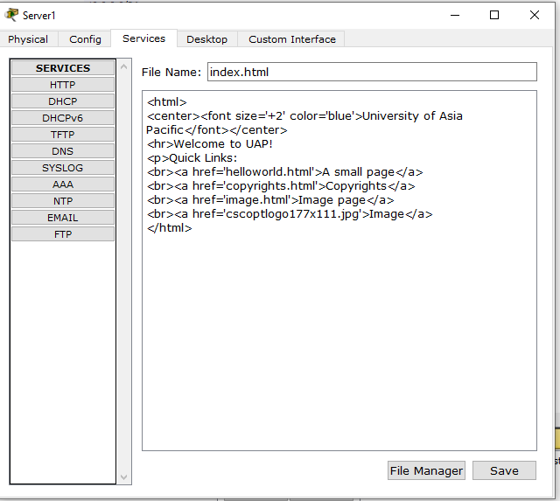

**Step-4:** Go to PC0, desktop and web browser then type the web address, it should be displayed. Also it can be accessed by the ip address.

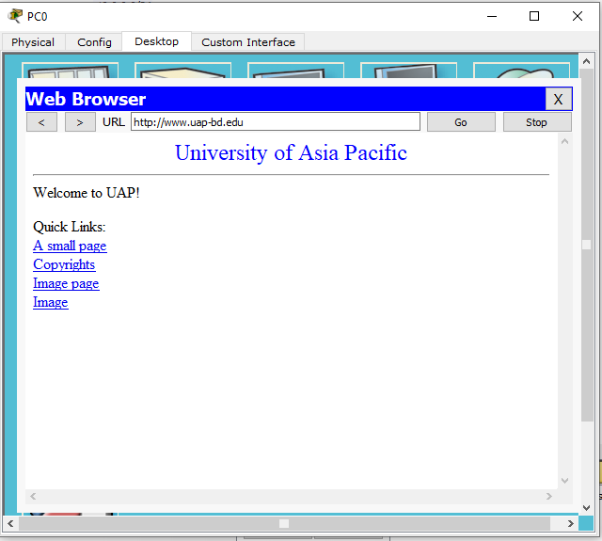

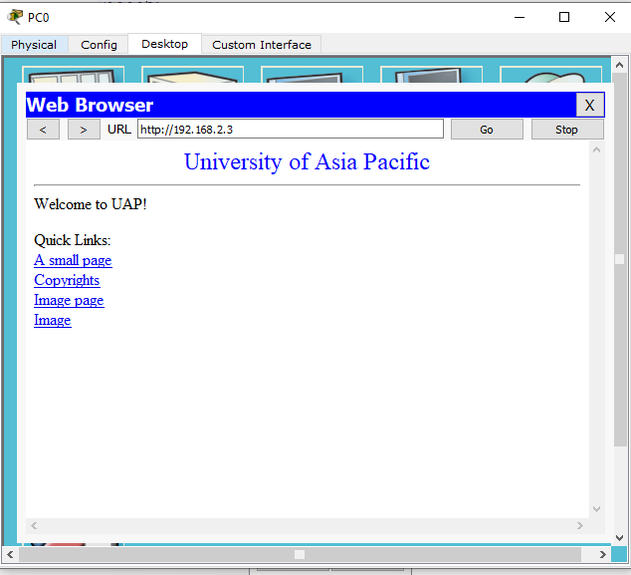

How to implement **FTP Server:**

**Step-1:** Give ip configuration on ftp server (server 2).

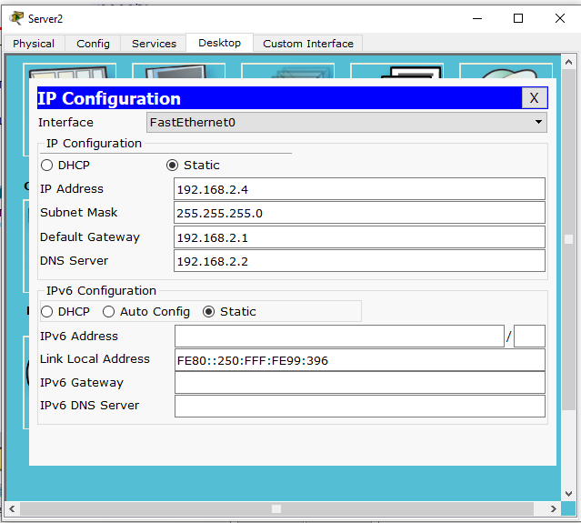

**Step-2:** Go to FTP server, choose FTP, add username, password with permissions.

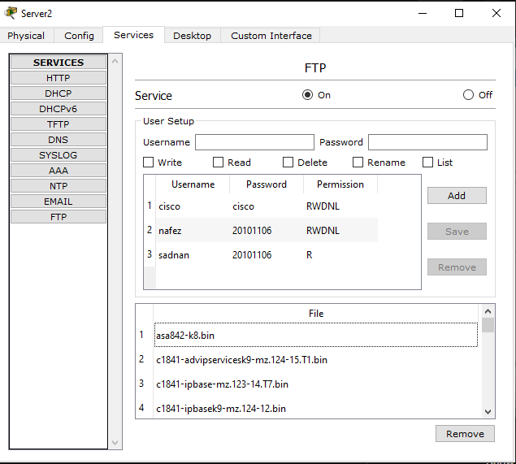

**Step-3:** Go to DNS server, then add FTP website.

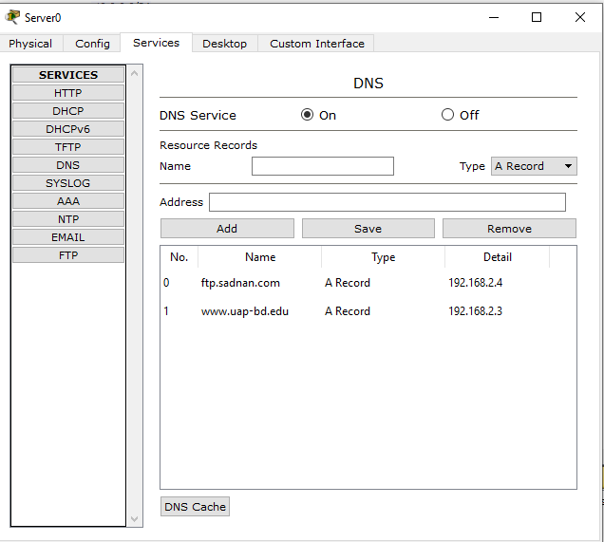

**Step-4:** Go to PC0, command prompt and log in.

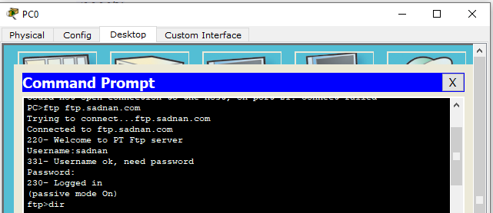

**Step-5:** Go to text editor of PC0 and make a text file.

**Step-6:** Put the hello.txt file and saw all files by dir command.

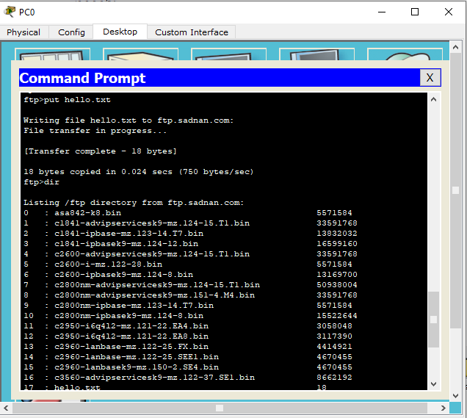

**Step-7:** Go to a viewer PC (PC1), then command prompt and download the hello.txt file from the FTP server by using get hello.txt.

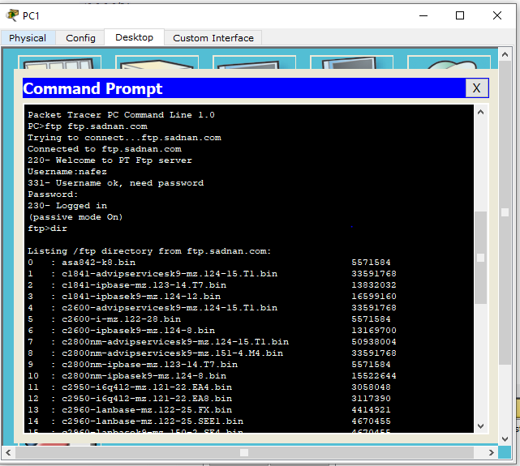

How to implement **EMAIL Server:**

**Step-1:** Give ip configuration on email server (server 3).

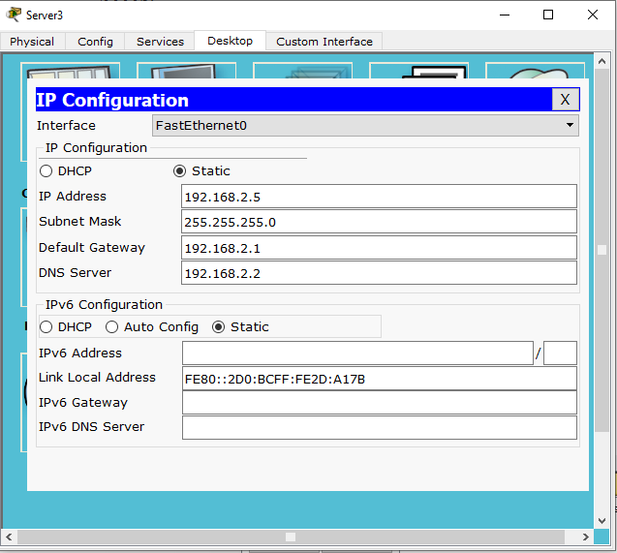

**Step-2:** Go to email on server 3, add domain name and admin-viewer with password. I’m using sadnan.com as domain name.

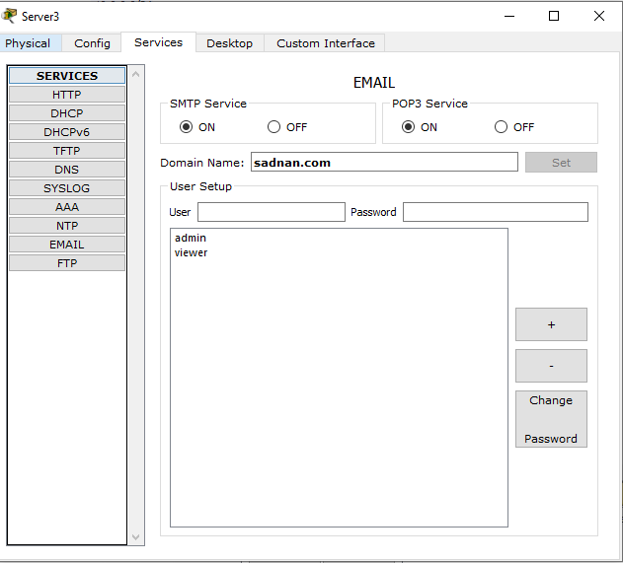

**Step-3:** Go to admin PC0 and configure the mail.

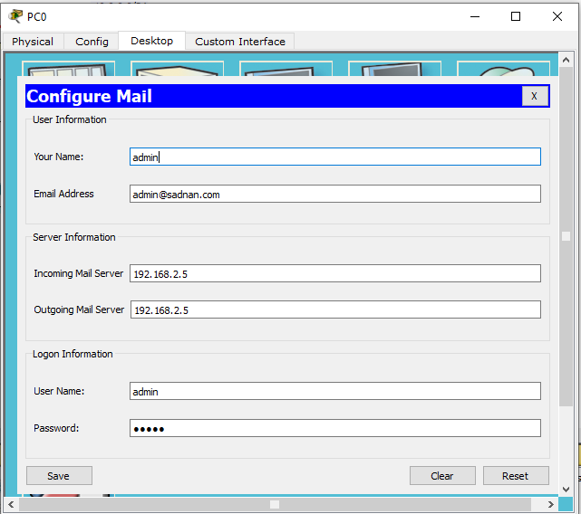

**Step-4:** Go to viewer PC1 and configure the mail.

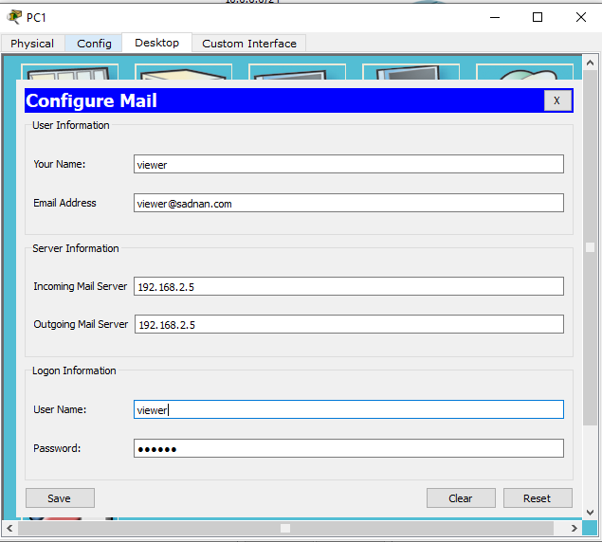

**Step-5:** Compose a mail.

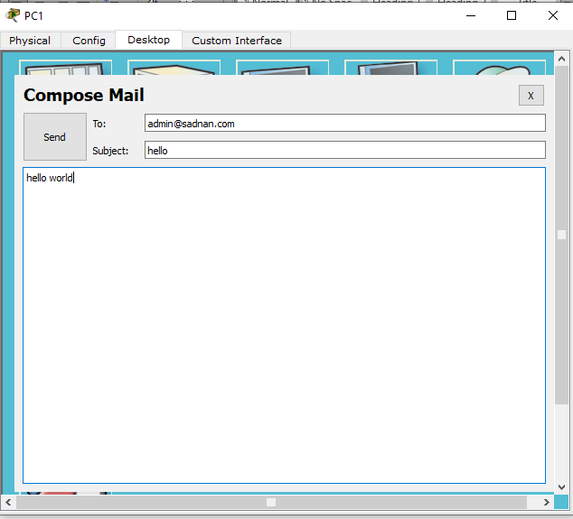

**Step-6:** Send the mail. It should succeed.

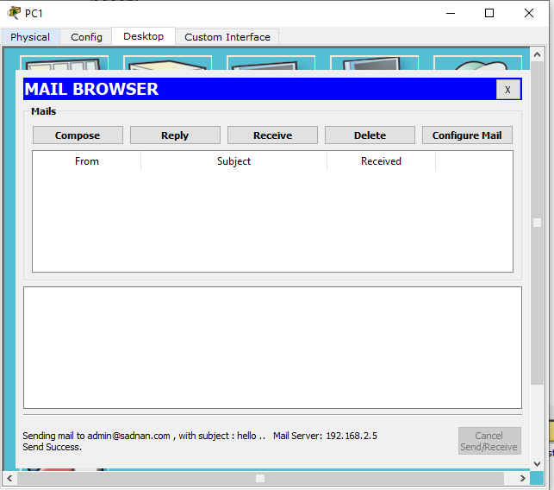

**Step-7:** Go to admin PC0 and receive the mail.

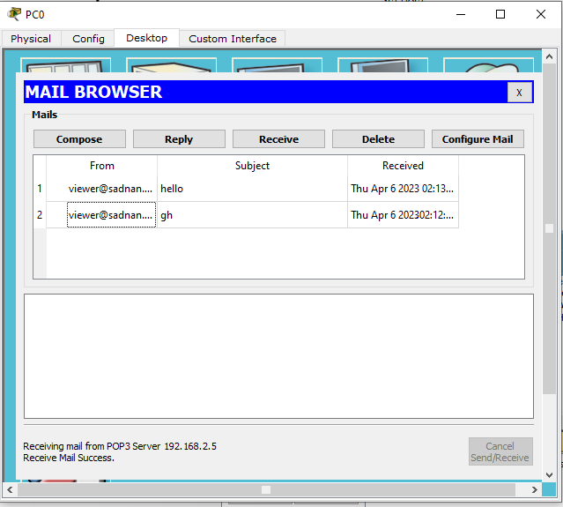

Check if all the servers (DNS, HTTP, FTP, EMAIL) are working properly,

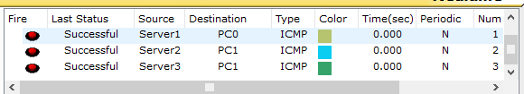

**Overall screenshot of the whole architecture-**

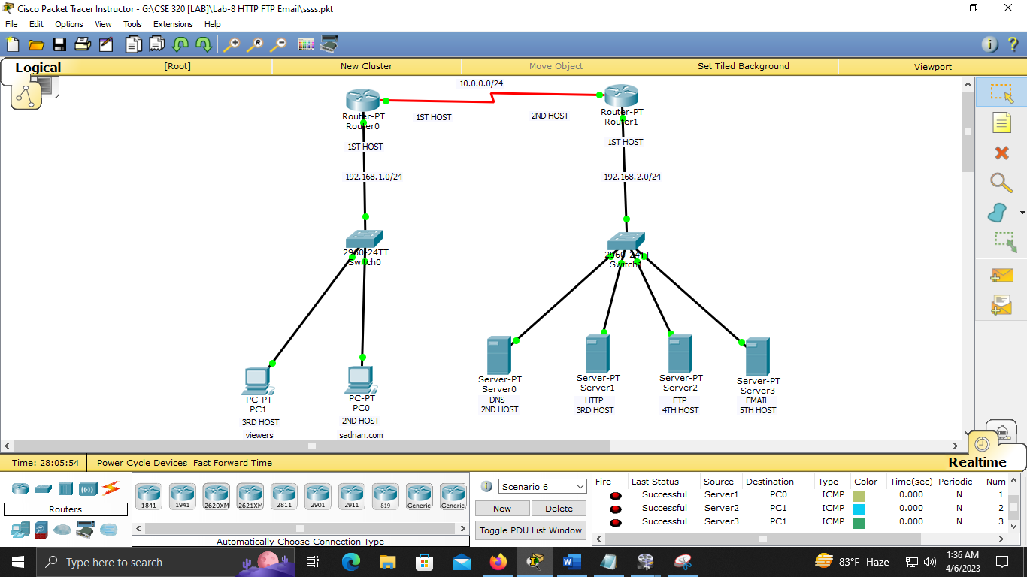

Detailed view-

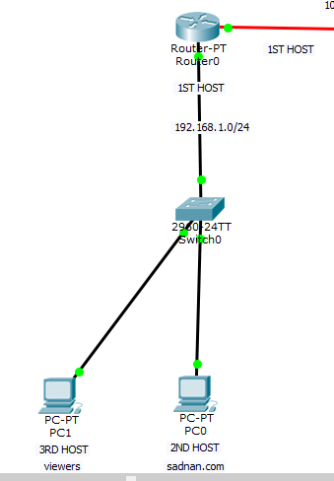

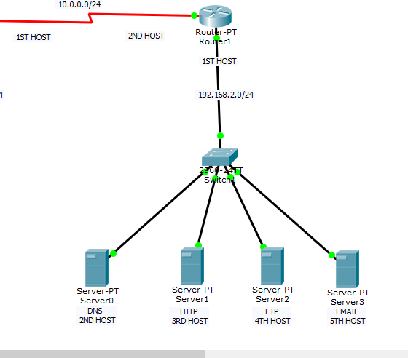

---------------------------THANK YOU FOR READING--------------------------